Assignment Day 20

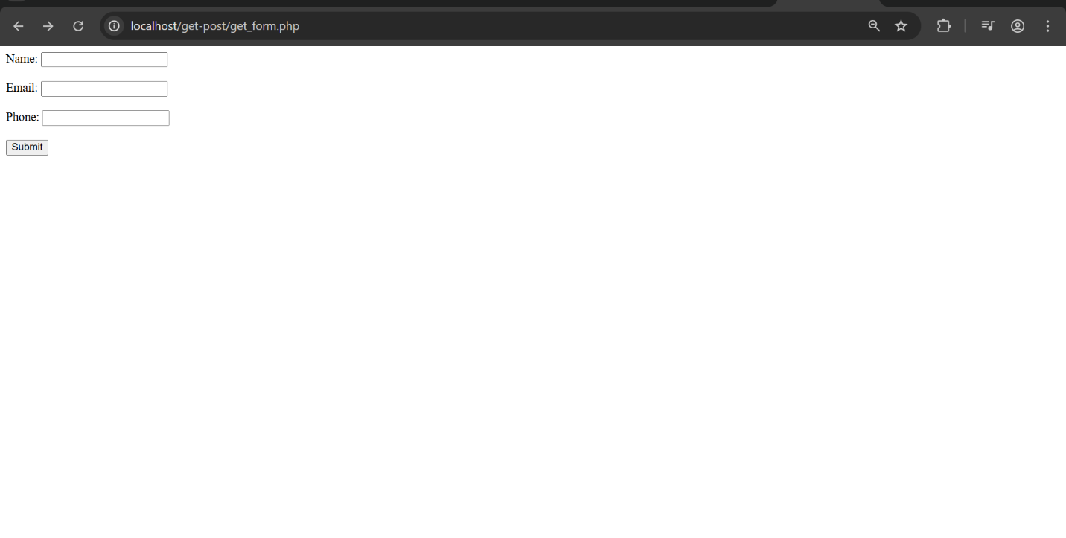

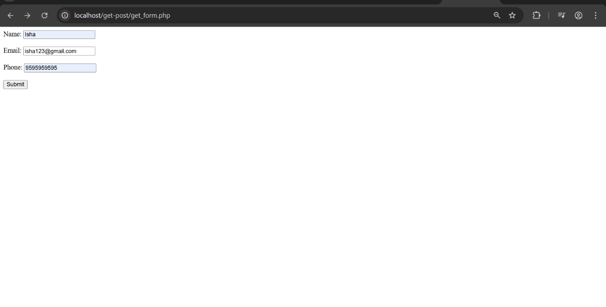

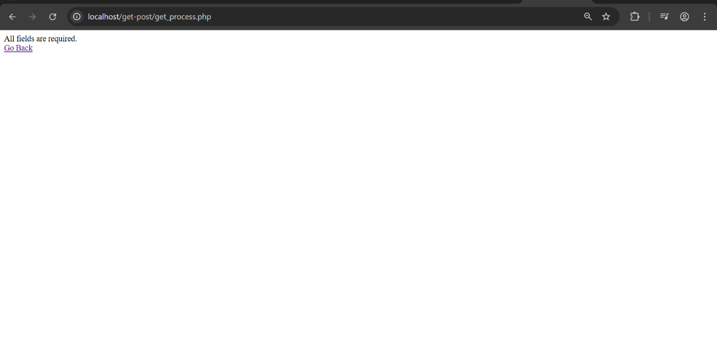

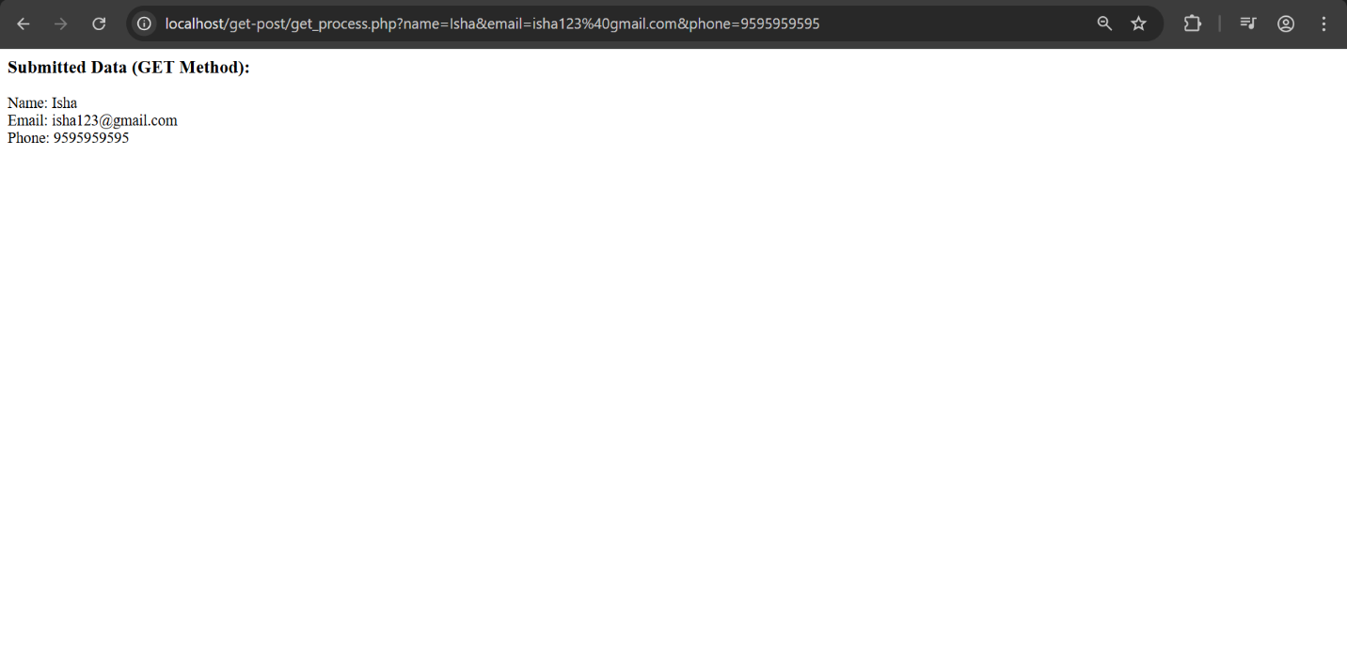

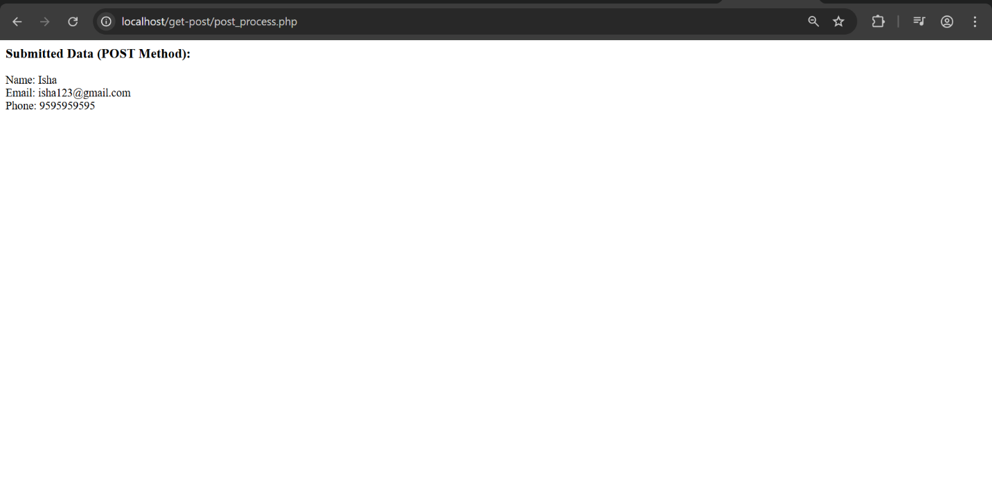

In this task, two registration forms were created — one using the **GET** method and another using the **POST** method. PHP was used to collect and display the submitted data on separate pages. Basic validation was added to check if all fields were filled, and error messages were shown for missing inputs. The forms were tested successfully on **localhost** using XAMPP.